REFRESHER LOGICAL THINKING AND BASIC CALCULATIONS

LEARNER GUIDE

Module Code | 252901001-KM-06
NQF Level | 4
Credits | 3
Curriculum Code | 252901001
Qualification Title | Occupational Certificate: Cybersecurity Analyst
SAQA QUAL ID | 118986

Name
Contact Address
Telephone (H)
Telephone (W)
Facsimile
Cellular
E-mail

Note to the learner
This Learner Guide provides a comprehensive overview of the module. It is designed to improve the skills and knowledge of learners, and thus enabling them to effectively and efficiently complete specific tasks.
Entry Requirements

- NQF 4
Provider Accreditation Requirements for the Knowledge Module

Physical Requirements
- The provider must have lesson plans and structured learning material or provide learners with access to structured learning material that addresses all the topics in all the knowledge modules as well as the applied knowledge in the practical skills.
- QCTO/ MICT SETA requirements

Human Resource Requirements:
- Lecturer/learner ratio of 1:20 (Maximum)
- Qualification of lecturer (SME):
    - NQF 6 in industry recognised qualifications with 1 years’ experience in the IT industry
    - CYBERSECURITY vendor certification
- Assessors and moderators: accredited by the MICT SETA
Legal Requirements
- Legal (product) licences to use the software for learning and training
- OHS compliance certificate
- Ethical clearance (where necessary)
Module Purpose
The main focus of the learning in this knowledge module is to acquire mathematical thinking theory for solving problems and acquire basic maths knowledge for using software toolkits or platforms

Topic elements to be covered include
The learning will enable learners to demonstrate an understanding of:
- KM-06-KT01: Mathematical thinking skills for problem solving.
- KM-06-KT02: Basic math
- KM-06-KT03: Conversion between decimal and binary systems
- KM-06-KT04: Express size and magnitude
- KM-06-KT05: Error in calculations
- KM-06-KT06: Cartesian coordinate system
- KM-06-KT07: Pythagorean theorem for finding the distance between two points
- KM-06-KT08: Operator precedence
- KM-06-KT09: Integer division
- KM-06-KT10: Modulus
- KM-06-KT11: Increments

Venue, Date and Time:
Consult your facilitator should there be any changes to the venue, date and/or time.
Refer to your timetable
Assessments

The only way to establish whether you are competent and have accomplished the learning outcomes is through continuous assessments. This assessment process involves interpreting evidence about your ability to perform certain tasks. You will be required to perform certain procedures and tasks during the training programmer and will be assessed on them to certify your competence.

This module includes assessments in the form of self-evaluations/activities and exercises. The exercises, activities and self-assessments will be done in pairs, groups or on your own. These exercises/activities or self-assessments (Learner workbook) must be handed to the facilitator. It will be added to your portfolio of evidence, which will be proof signed by your facilitator that you have successfully performed these tasks.

Listen carefully to the instructions of the facilitator and do the given activities in the time given to you.

KM-06-KT01: Mathematical thinking skills for problem solving. Learning Outcome
- KT0101 Benefits of mathematics
- KT0102 Mathematical thinking steps for solving problems:
    - Break task down into components
    - Identify similar tasks that may help
    - Identify appropriate knowledge and skills
    - Identify assumptions
    - Select appropriate strategy
    - Consider alternative approaches
    - Look for a pattern or connection
    - Generate examples

- KT0101 Benefits of mathematics
Here are six more reasons to study mathematics.
- Excellent for your brain. Creative and analytical skills are highly desired by employers. ...
- Real-world applications.
- Better problem-solving skills.
- Helps almost every career.
- Helps understand the world better.
- It is the universal language.
Why is mathematics important for students?
Mathematics provides an effective way of building mental discipline and encourages logical reasoning and mental rigor. In addition, mathematical knowledge plays a crucial role in understanding the contents of other school subjects such as science, social studies, and even music and art.

1. Excellent for your brain
Creative and analytical skills are highly desired by employers. Our brains develop important neural pathways for processing information and it’s no surprise that mathematics plays an important role in brain development and analytical skills. Akshay for Life Hacks explains, “When we do a mathematical problem: collect the data, break down its premises, observe the relations that keep or systematically solve their parts in a rational way. If we are able to understand mathematics and arrive at logical solutions, we will be able to prepare our minds when we have real problems. We can look for the best logic, see the possible solutions and relate the data we have to reach the conclusion.”

Recent research by Dr. Tanya Evans of Stanford University shows, “Children who know math are able to recruit certain brain regions more reliably, and have greater gray matter volume in those regions, than those who perform more poorly in math. The brain regions involved in higher math skills in high-performing children were associated with various cognitive tasks involving visual attention and decision-making.” Tim Radford writes in The Guardian, “Maths is one of the best ways to strengthen a brain. [...] The research shows that maths is good for all of your brain, not just the parts that other activities cannot reach." As a mathematics student, not only will you deepen your knowledge of the field, you’ll also improve your brain power.

2. Real-world applications
Your intensive study in mathematics will be applied immediately to solving real-world problems. Are you going to be purchasing a house? Navigating percentages and mortgage rates is directly related to understanding mathematics basics. Do you regularly use a computer and social media? Mathematics is embedded into computer technology and it would not exist without it.

Katie Kim, for Plexxus, writes, “Math is needed for almost every single profession in the world. If you want to be a CEO, a real estate agent, a biologist, or even a rocket scientist, it is without a doubt that numbers will be utilized. Basically, you will NEVER be able to escape math and you might as well accept it and have fun learning it while your career does not depend on it.”

3. Better problem-solving skills
Potentially none of us will approach Alan Turing’s mathematical and problem-solving genius -- Turing is credited with being the father of modern computing; he cracked the Nazis' Enigma code, among many other important mathematical advances -- but there’s no doubt that becoming more competent in mathematics and studying it seriously can advance your problem-solving skills.

Mathematics provides clarity in problem solving and “mathematicians have always understood that problem-solving is central to their discipline because without a problem there is no mathematics. Problem-solving has played a central role in the thinking of educational theorists,” writes Jacob Klerlein and Sheena Hervey for Generation Ready. As a student of mathematics, you’ll develop better systems for problem-solving, learning how applied mathematics solves real-world issues.

4. Helps almost every career
Knowledge of mathematics, and its complexities, can help in almost every career. The American Mathematical Society says a career centered on mathematics provides many opportunities: “Mathematical research and education are at the heart of some careers, while other careers utilize mathematics and its applications to build and enhance important work in the sciences, business, finance, manufacturing, communications, and engineering.” Some careers and jobs that benefit from a degree in mathematics include engineers, computer programmers, statisticians, actuaries, mathematics teachers, and even business managers. All of these careers appear to be different, but the one thing they have in common is that each of them require a strong developed skill set in mathematics.

5. Helps understand the world better
Studying mathematics allows you to understand the world better. This seems obvious, but knowing the nuances behind how mathematics works can open your eyes and help you see the world around you in a new way. For example, Einstein’s theory or relativity (what we perceive as the force of gravity in fact arises from the curvature of space and time; and objects such as the sun and the Earth change this geometry) is instrumental in furthering our understanding of the universe.

In fact, according to Natalie Wolchover in Quanta Magazine, this theory “showed that there’s a give-and-take to space and time, which together make up the bendy, warping “space-time” fabric. Thinking this way led [Einstein] and others to a closer examination of the symmetries of the universe, or all the ways you can shift, rotate and move through it and still measure the same separation between objects or events as before. It is in the language of these symmetries that relativity simplified our mathematical description of the universe.” Yes, mathematics can unlock the mysteries of the universe!

6. It is the universal language

Mathematics is the “universal language,” meaning it is the one language in the world that is universally understood across different cultures, countries, and languages. The simple arithmetic of 2+2=4 is the same around the world. For example, Barbara Oakley writes in Nautilus about how she rewired her brain to become fluent in math: “When learning math and engineering as an adult, I began by using the same strategy I’d used to learn language. I’d look at an equation, to take a very simple example, Newton’s second law of f = ma. [...] I memorized the equation so I could carry it around with me in my head and play with it.”

- KT0102 Mathematical thinking steps for solving problems:

Four-step process for problem solving, which is used all over to aid people in problem solving:
Step 1: Understand the problem.
Sometimes the problem lies in understanding the problem. If you are unclear as to what needs to be solved, then you are probably going to get the wrong results. In order to show an understanding of the problem, you, of course, need to read the problem carefully. Sounds simple enough, but some people jump the gun and try to start solving the problem before they have read the whole problem. Once the problem is read, you need to list all the components and data that are involved. This is where you will be assigning your variable.
Step 2: Devise a plan (translate).
When you devise a plan (translate), you come up with a way to solve the problem. Setting up an equation, drawing a diagram, and making a chart are all ways that you can go about solving your problem.

Step 3: Carry out the plan (solve).
The next step, carry out the plan (solve), is big. This is where you solve the equation you came up with in your 'devise a plan' step. The equations in this tutorial will all be linear equations.
Step 4: Look back (check and interpret).
You may be familiar with the expression 'don't look back'. In problem solving it is good to look back (check and interpret).. Basically, check to see if you used all your information and that the answer makes sense. If your answer does check out, make sure that you write your final answer with the correct labeling.

Numeric Word Problems
A lot of numeric types of word problems revolve around translating English statements into mathematical ones.
Just read and translate it left to right to set up your equation
 Example 1: Twice the difference of a number and 1 is 4 more than that number. Find the number.

Step 1: Understand the problem.
Make sure that you read the question carefully several times.
Since we are looking for a number, we will let
x = a number

Step 2: Devise a plan (translate).

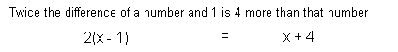

Step 3: Carry out the plan (solve).

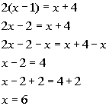 | *Remove ( ) by using dist. prop.  *Get all the x terms on one side  *Inv. of sub. 2 is add 2

Step 4: Look back (check and interpret).
If you take twice the difference of 6 and 1, that is the same as 4 more than 6, so this does check.
FINAL ANSWER: The number is 6.

Example 2: One number is 3 less than another number. If the sum of the two numbers is 177, find each number.

Step 1: Understand the problem.

Make sure that you read the question carefully several times.
We are looking for two numbers, and since we can write the one number in terms of another number, we will let
x = another number

ne number is 3 less than another number:
x - 3 = one number

Step 2: Devise a plan (translate).



Step 3: Carry out the plan (solve).

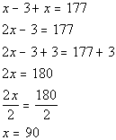 | *Combine like terms  *Inv. of sub 3 is add 3  *Inv. of mult. 2 is div. 2

Step 4: Look back (check and interpret).

If we add 90 and 87 (a number 3 less than 90) we do get 177.
FINAL ANSWER: One number is 90. Another number is 87.

Percent Problems

Whenever you are working with a percent problem, you need to make sure you write your percent in decimal form. You do this by moving the decimal place of the percent two to the left. For example, 32% in decimal form is .32
When you are wanting to find the percentage of some number, remember that ‘of ’ represents multiplication - so you would multiply the percent (in decimal form) times the number you are taking the percent of.
Example 3: Find 45% of 125.

Step 1: Understand the problem.
Make sure that you read the question carefully several times.
We are looking for a number that is 45% of 125, we will let
x = the value we are looking for

Step 2: Devise a plan (translate).



Step 3: Carry out the plan (solve).

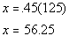 | *Multiply

Step 4: Look back (check and interpret).

56.25 is 45% of 125.
FINAL ANSWER: The number is 56.25.

Example 4: A math class has 30 students. Approximately 70% passed their last math test. How many students passed the last math test?

Step 1: Understand the problem.

Make sure that you read the question carefully several times.
We are looking for how many students passed the last math test, we will let
x = number of students

Step 2: Devise a plan (translate).



Step 3: Carry out the plan (solve).

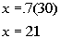 | *Multiply

Step 4: Look back (check and interpret).

21 is 70% of 30.
FINAL ANSWER: 21 students passed the last math test.

Example 5: I purchased a new tv at a local electronics store for R541.25, which included tax. If the tax rate is 8.25%, find the price of the tv before they added the tax.

Step 1: Understand the problem.

Make sure that you read the question carefully several times.
We are looking for the price of the tv before they added the tax, we will let
x = price of the tv before tax was added.

Step 2: Devise a plan (translate).



Step 3: Carry out the plan (solve).

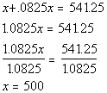 | *Combine like terms  *Inv of mult. 1.0825 is div. by 1.0825

Step 4: Look back (check and interpret).

If you add on 8.25% tax to 500, you would get 541.25.
FINAL ANSWER: The original price is R500.

Rectangle Problem

The following formula will come in handy for solving example 6:
Perimeter of a Rectangle = 2(length) + 2(width)

Example 6: In a blueprint of a rectangular room, the length is 1 inch more than 3 times the width. Find the dimensions if the perimeter is to be 26 inches.

Step 1: Understand the problem.

Make sure that you read the question carefully several times.
We are looking for the length and width of the rectangle. Since length can be written in terms of width, we will let
w = width

length is 1 inch more than 3 times the width:
1 + 3w = length

Step 2: Devise a plan (translate).



Step 3: Carry out the plan (solve).

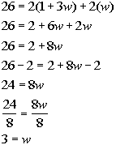 | *Remove ( ) by using dist. prop.  *Combine like terms  *Inv. of add. 2 is sub. 2  *Inv. of mult. by 8 is div. by 8

Step 4: Look back (check and interpret).

If width is 3, then length, which is 1 inch more than 3 times the width would have to be 10. The perimeter of a rectangle with width of 3 inches and length of 10 inches does come out to be 26.
FINAL ANSWER: Width is 3 inches. Length is 10 inches.

Supplementary and Complementary angles

Supplementary angles sum up to be 180 degrees.
Complimentary angles sum up to be 90 degrees.

Example 7: Find the measure of each angle in the figure below. Note that since the angles make up a straight line, they are supplementary to each other.
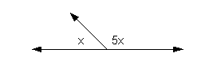

Step 1: Understand the problem.

Make sure that you read the question carefully several times.
We are already given in the figure that
x = one angle
5x = other angle

Step 2: Devise a plan (translate).



Step 3: Carry out the plan (solve).

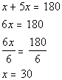 | *Combine like terms  *Inv. of mult. by 6 is div. by 6

Step 4: Look back (check and interpret).

If x is 30, then 5x = 5(30) = 150. 150 and 30 do add up to be 180, so they are supplementary angles.
FINAL ANSWER: The two angles are 30 degrees and 150 degrees.

Consecutive Integers

Consecutive integers are integers that follow one another in order.
For example, 5, 6, and 7 are three consecutive integers.
If we let x represent the first integer, how would we represent the second consecutive integer in terms of x? Well if we look at 5, 6, and 7 - note that 6 is one more than 5, the first integer.
In general, we could represent the second consecutive integer by x + 1. And what about the third consecutive integer.
Well, note how 7 is 2 more than 5. In general, we could represent the third consecutive integer as x + 2.

Consecutive EVEN integers are even integers that follow one another in order.
For example, 4, 6, and 8 are three consecutive even integers.
If we let x represent the first EVEN integer, how would we represent the second consecutive even integer in terms of x? Note that 6 is two more than 4, the first even integer.
In general, we could represent the second consecutive EVEN integer by x + 2.
And what about the third consecutive even integer? Well, note how 8 is 4 more than 4. In general, we could represent the third consecutive EVEN integer as x + 4.

Consecutive ODD integers are odd integers that follow one another in order.
For example, 5, 7, and 9 are three consecutive odd integers.
If we let x represent the first ODD integer, how would we represent the second consecutive odd integer in terms of x? Note that 7 is two more than 5, the first odd integer.
In general, we could represent the second consecutive ODD integer by x + 2.
And what about the third consecutive odd integer? Well, note how 9 is 4 more than 5. In general, we could represent the third consecutive ODD integer as x + 4.
Note that a common misconception is that because we want an odd number that we should not be adding a 2 which is an even number. Keep in mind that x is representing an ODD number and that the next odd number is 2 away, just like 7 is 2 away form 5, so we need to add 2 to the first odd number to get to the second consecutive odd number.

Example 8: The sum of 3 consecutive integers is 258. Find the integers.

Step 1: Understand the problem.

Make sure that you read the question carefully several times.
We are looking for 3 consecutive integers, we will let
x = 1st consecutive integer
x + 1 = 2nd consecutive integer
x + 2 = 3rd consecutive integer

Step 2: Devise a plan (translate).

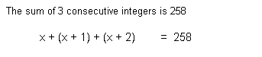

Step 3: Carry out the plan (solve).

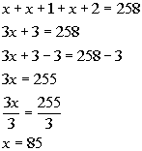 | *Combine like terms  *Inv. of add 3 is sub. 3  *Inv. of mult. by 3 is div. by 3

Step 4: Look back (check and interpret).

The sum of 85, 86 and 87 does check to be 258.
FINAL ANSWER: The three consecutive integers are 85, 86, and 87.

Example 9: The ages of 3 sisters are 3 consecutive even integers. If the sum of twice the 1st even integer, 3 times the 2nd even integer, and the 3rd even integer is 34, find each age.

Step 1: Understand the problem.

Make sure that you read the question carefully several times.
We are looking for 3 EVEN consecutive integers, we will let
x = 1st consecutive even integer
x + 2 = 2nd consecutive even integer
x + 4 = 3rd consecutive even integer

Step 2: Devise a plan (translate).



Step 3: Carry out the plan (solve).

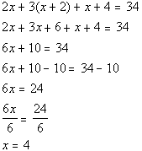 | *Remove ( ) by using dist. prop.  *Combine like terms  *Inv. of add. 10 is sub. 10  *Inv. of mult. by 6 is div. by 6

Step 4: Look back (check and interpret).

If we take the sum of two times 4, three times 6, and 8, we do get 34
FINAL ANSWER: The ages of the three sisters are 4, 6, and 8.

Business Problem: Breaking Even

In a business-related problem, the cost equation, C is the cost of manufacturing a product.
In the revenue equation, R is the amount of money the manufacturer makes on a product.
If a manufacturer wants to know how many items must be sold to break even, that can be found by setting the cost equal to the revenue.

Example 10: The cost C to produce x number of cd’s is C = 50 + 5x. The cd’s are sold wholesale for R15 each, so revenue R is given by R = 15x. Find how many cd’s the manufacturer needs to produce and sell to break even.

Step 1: Understand the problem.

Make sure that you read the question carefully several times.
We are looking for the number of cd’s needed to be sold to break even, we will let
x = the number of cd’s

Step 2: Devise a plan (translate).

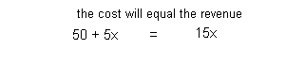

Step 3: Carry out the plan (solve).

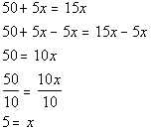 | *Get all x terms on one side  *Inv. of mult. by 10 is div. by 10

Step 4: Look back (check and interpret).

When x is 5 the cost and the revenue both equal 75.
FINAL ANSWER: 5 cd’s.
 Practice Problems

These are practice problems to help bring you to the next level. It will allow you to check and see if you have an understanding of these types of problems. Math works just like anything else, if you want to get good at it, then you need to practice it. Even the best athletes and musicians had help along the way and lots of practice, practice, practice, to get good at their sport or instrument. In fact there is no such thing as too much practice.
To get the most out of these, you should work the problem out on your own and then check your answer by clicking on the link for the answer/discussion for that problem. At the link you will find the answer as well as any steps that went into finding that answer.
 Practice Problems 1a - 1g: Solve the word problem.

1a. The sum of a number and 2 is 6 less than twice that number.
(answer/discussion to 1a)

1b. Find 72% of 35.
(answer/discussion to 1b)

1c. A local furniture store is having a terrific sale. They are marking down every price 45%. If the couch you have our eye on is R440 after the markdown, what was the original price? How much would you save if you bought it at this sale?
(answer/discussion to 1c)

1d. A rectangular garden has a width that is 8 feet less than twice the length. Find the dimensions if the perimeter is 20 feet.
(answer/discussion to 1d)

1e. Complimentary angles sum up to be 90 degrees. Find the measure of each angle in the figure below. Note that since the angles make up a right angle, they are complementary to each other.
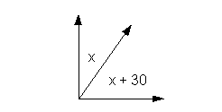
(answer/discussion to 1e)

1f. The sum of 3 consecutive odd integers is 57. Find the integers.
(answer/discussion to 1f)

1g. The cost C to produce x numbers of VCR’s is C = 1000 + 100x. The VCR’s are sold wholesale for R150 each, so the revenue is given by R = 150x. Find how many VCR’s the manufacturer needs to produce and sell to break even.
(answer/discussion to 1g)

Internal Assessment Criteria and Weight
- IAC0101 Problem solving as a complex and reiterative process is reasoned

KM-06-KT02 : Basic Math
Learning Outcome

KT0201 | Arithmetic expressions in programming: Addition (+), subtraction (-), multiplication (*) and  division (/) for both integers and real data types
KT0202 | Percentage
KT0203 | Negative numbers

- KT0201 Arithmetic expressions in programming: Addition (+), subtraction (-), multiplication (*) and division (/) for both integers and real data types
Arithmetic expressions play a fundamental role in programming as they allow us to perform mathematical calculations and manipulate numerical data. The four basic arithmetic operators - addition (+), subtraction (-), multiplication (*), and division (/) - are essential tools for working with both integers and real data types.

Addition (+) is used to combine two or more numbers together, resulting in their sum. For example, in the expression 2 + 3, the operator "+" adds the numbers 2 and 3, yielding a result of 5.

Subtraction (-) is used to find the difference between two numbers. It subtracts the second number from the first. For instance, in the expression 5 - 2, the operator "-" subtracts 2 from 5, resulting in 3.

Multiplication () is employed to multiply two or more numbers together, producing their product. For example, in the expression 4 * 3, the operator "" multiplies the numbers 4 and 3, yielding a result of 12.

Division (/) allows us to divide one number by another. It calculates the quotient, which can vary depending on the data types involved. When dividing integers, the result will be an integer quotient, discarding any remainder. For instance, in the expression 10 / 3, the operator "/" divides 10 by 3, resulting in an integer quotient of 3. However, when dividing real numbers, such as in the expression 10.0 / 3.0, the operator "/" will produce a real quotient with decimal precision.

It is important to note that when working with arithmetic expressions, the order of operations matters. Parentheses can be used to specify the desired order and override the default precedence rules. For example, in the expression (2 + 3) * 4, the parentheses ensure that the addition operation is performed first, resulting in a sum of 5, which is then multiplied by 4 to yield a final result of 20.

In programming languages, arithmetic expressions are typically written using a combination of operators and operands. Operands can be literals (specific values) or variables (representing values stored in memory). The result of an arithmetic expression can be assigned to a variable or used directly in further calculations.

By understanding and utilizing arithmetic expressions and their operators effectively, programmers can perform complex calculations, manipulate numerical data, and solve various mathematical problems within their programs.

- KT0202 Percentage
A percentage is a way of expressing a fraction or a proportion as a number out of 100.
The symbol for percentage is "%".
Percentages are commonly used in many fields, including finance, science, and statistics.
To calculate a percentage, divide the part by the whole and multiply by 100. For example, if 25 out of 100 students passed an exam, the percentage of students who passed is (25/100) x 100 = 25%.
Percentages can also be used to calculate changes or differences between two values. To find the percentage change, divide the difference between the two values by the original value and multiply by 100. For example, if the price of an item increases from 50 ZAR to 60 ZAR, the percentage change is ((60-50)/50) x 100 = 20%.
Percentages can be represented as decimals or fractions. For example, 25% can be written as either 0.25 or 1/4.
Percentages can be added, subtracted, multiplied, and divided like any other numbers. For instance, if a store offers a 20% discount on a 50 ZAR item, the discounted price would be 40 ZAR (50 x 0.8).
Percentages can also be used to calculate compound interest, which is interest that is calculated on both the principal amount and any accumulated interest. Compound interest can result in significant growth over time, making it an important concept in finance.
Understanding percentages is essential for many everyday tasks such as calculating discounts, tax rates, and interest rates using South African Rands. It is also important in fields such as statistics, where percentages are used to represent data in a meaningful way. By mastering the basics of percentages, individuals can make informed decisions and perform calculations accurately and efficiently.

- KT0203 Negative numbers
Negative numbers are numbers less than zero and are represented with a negative sign (-).
Negative numbers can be used to represent values such as debts, losses, and temperatures below zero.
Negative numbers can be added, subtracted, multiplied, and divided like any other numbers.
When adding or subtracting negative numbers, the two negative signs cancel each other out and the operation is treated as if it were addition or subtraction of positive numbers. For example, (-3) + (-4) = -(3 + 4) = -7.
When multiplying or dividing two negative numbers, the result is positive. For example, (-2) x (-3) = 6.
When multiplying or dividing a negative number by a positive number, the result is negative. For example, (-2) x 3 = -6.
When dividing a positive number by a negative number, the result is negative. For example, 6 / (-2) = -3.
Negative numbers can be compared to other numbers using the same comparison operators as positive numbers (<, >, <=, >=). For example, -5 < 0 and -2 > -3.
Negative numbers can be represented as fractions or decimals. For example, -1/2 or -0.5.
Understanding negative numbers is essential in many fields, including mathematics, science, and finance. By mastering the basics of negative numbers and their operations, individuals can perform calculations accurately and efficiently. Negative numbers are also important in many real-world applications and can be used to represent values such as debts, losses, and temperatures below zero.

KM-06-KT03 : Conversion between decimal and binary systems
Learning Outcome

- KT0201 Introduction to binary numbers
- KT0202 Performing addition and subtraction of positive whole numbers in binary
- KT0203 Binary arithmetic
- KT0204 Use of BODMAS

- KT0201 Introduction to binary numbers
What is binary?
Binary is a base-2 number system, which only uses two digits (0 & 1). It is a system used at the heart of every digital computer, allowing them to encode information, perform arithmetic operations and execute logical control processes.

Using two digits as opposed to, say, the familiar ten digits used in decimal systems (0 to 9) enables hardware to be easily implemented via simple ‘on’ or ‘off’ circuit states or logic gates. This is the basis for all digital systems.

What is binary number example?
A method of representing numbers that has 2 as its base and uses only the digits 0 and 1. Each successive digit represents a power of 2. For example, 10011 represents (1 X 24) + (0 X 23) + (0 X 22) + (1 X 21) + (1 X 20), or 16 + 0 + 0 + 2 + 1, or 19.
Binary is a numerical notation system that uses 2 as a base. Most often, numbers are represented by the Decimal system, which is base 10.
Decimal: (deci)mal → (deci) meaning 10. → 110
Binary: (bi)nary → (bi) meaning 2. → 12
In the decimal system, there are ten unique numbers: 0,1,2,3,4,5,6,7,8,9.
In the binary system there are only two unique numbers: 0,1.
Each number in commonly referred to as a "bit"
Examples of Binary:
100 = 4. There is one value of 22.
101 = 5. There is one value of 22 and one value of 20.
These values are added: 4 + 1 = 5.
001 = 1. There is one value of 20.
10011 = 19. There is one value of 24, one value of 21, and one value of 20.
These values are added: 16 + 2 + 1 = 19.

- KT0202 Performing addition and subtraction of positive whole numbers in binary
To understand binary values imagine each digit (or ‘bit’) of the binary notation as representing an increasing power of 2 - with the rightmost digit representing 20, the next representing 21, then 22 and so on.

For each bit, the 1 or 0 signifies whether the value of the increasing power of two summates towards the number's total.
2^{n} | 2³ | 2² | 2¹ | 2⁰
Decimal | 8 | 4 | 2 | 1

Increasing powers of two represented with its decimal result.
As a visual example, figure 2 shows the binary value 1100 converted into the decimal value 12. Blue numbers represent the binary notation, red numbers represent the increasing powers of 2, and green numbers represent the decimal values.

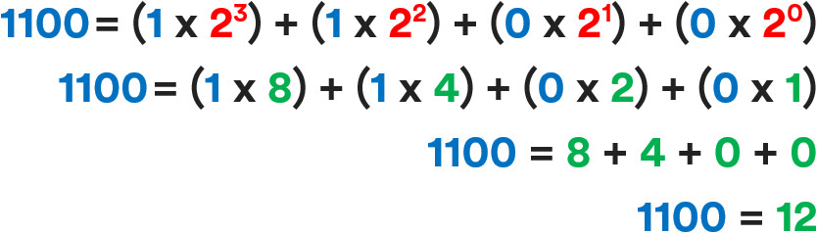

- KT0203 Binary arithmetic
Binary arithmetic includes the basic arithmetic operations of addition, subtraction, multiplication and division. The following sections present the rules that apply to these operations when they are performed on binary numbers. Binary Addition: Binary addition is performed in the same way as addition in the decimal-
Why is binary arithmetic?
Binary arithmetic is an essential part of various digital systems. You can add, subtract, multiply, and divide binary numbers using various methods. These operations are much easier than decimal number arithmetic operations because the binary system has only two digits: 0 and
Binary Addition
It is a key for binary subtraction, multiplication, division. There are four rules of binary addition.

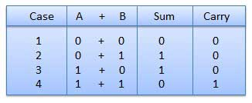
In fourth case, a binary addition is creating a sum of (1 + 1 = 10) i.e. 0 is written in the given column and a carry of 1 over to the next column.

Example − Addition
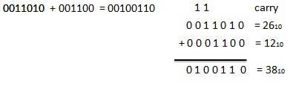
Binary Subtraction
Subtraction and Borrow, these two words will be used very frequently for the binary subtraction. There are four rules of binary subtraction.
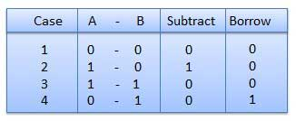
Example – Subtraction
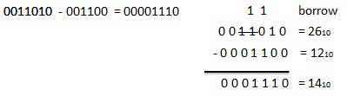

Binary Multiplication
Binary multiplication is similar to decimal multiplication. It is simpler than decimal multiplication because only 0s and 1s are involved. There are four rules of binary multiplication.
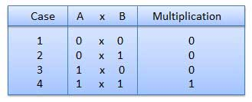
Example – Multiplication

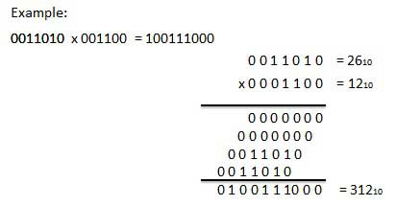

Binary Division
Binary division is similar to decimal division. It is called as the long division procedure.

Example − Division
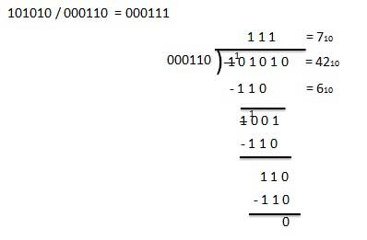

- KT0204 Use of BODMAS
What is the BODMAS rule?
BODMAS rule is an acronym to help children to remember the order of operations in calculations. Operations are simply the different things that we can do to numbers in maths. It stands for, 'Brackets, Order, Division, Multiplication, Addition, Subtraction.'

There is sometimes some confusion over the meaning of ‘order’ in BODMAS. Order simply refers to square roots or square numbers. BODMAS is sometimes known as BIDMAS. In that acronym, the I stands for indices, which are the small numbers used to show that a number has been multiplied by itself (that it is a square number). We'll explain a bit more about BIDMAS later on.

Using the BODMAS rule means starting by solving any calculation in brackets, then finding the square or square root of any numbers and so on, with any subtraction calculation taking place last.

Although, it's important to remember that multiplication and division should be completed in order of left to right, whichever comes first. This is also the same for addition and subtraction.

BODMAS rule is an acronym to help children to remember the order of operations in calculations. Operations are simply the different things that we can do to numbers in maths. It stands for, 'Brackets, Order, Division, Multiplication, Addition, Subtraction.
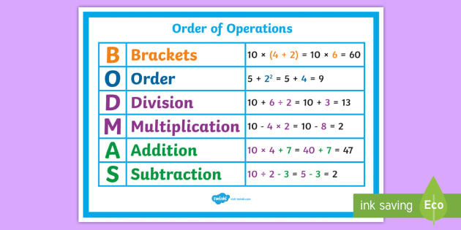

Internal Assessment Criteria and Weight
- IAC0201 Conversions between decimal and binary systems and the application thereof are explained

KM-06-KT04 : Express size and magnitude
Learning Outcome
- KT0301 Use scientific notation for small and large numbers
- KT0302 Prefixes: From Giga to Pica (109 to 10 -12)
- KT0303 Conversions: SI to Imperial: degrees F to degrees C

- KT0301 Use scientific notation for small and large numbers
Scientific notation is a way of writing very large or very small numbers. A number is written in scientific notation when a number between 1 and 10 is multiplied by a power of 10. For example, 650,000,000 can be written in scientific notation as 6.5 ✕ 10^8.
What is scientific notation?
The concept of very large or very small numbers is something that is difficult for many students to comprehend. In general, students have difficulty with two things when dealing with numbers that have more zeros (either before OR after the decimal point) than they are used to. They often do not understand:

- that "big" and "small" are relative terms,
- the concept of "order of magnitude"
Scientific notation is a way to assess the order of magnitude and to visually decrease the zeros that the student sees. It also may help students to compare very large (or very small numbers) But students still have little intuition about scientific notation. Teaching them to recognize that scientific notation is a short hand way to better understand big and small numbers can be useful to them in all aspects of their academic career.

In science, often we work with very large or very small numbers. For example, in geology,
the age of the Earth = 4,600,000,000 years old,
or, in chemistry,
one a.m.u. = 0.00000000000000000000000000166 kilograms.
It seems like a lot of work to keep track of all those zeros. Fortunately, we can easily keep track of zeros and compare the size of numbers with scientific notation.
Scientific notation allows us to reduce the number of zeros that we see while still keeping track of them for us. For example the age of the Earth (see above) can be written as 4.6 X 10⁹ years. This means that this number has 9 places after the decimal place - filled with zeros unless a number comes after the decimal when writing scientific notation. So 4.6 X 10⁹ years represents 4600000000 years.
Very small numbers use the same type of notation only the exponent on the 10 is usually a negative number. For example, 0.00000000000000000000000000166 kg (the weight of one atomic mass unit (a.m.u.)) would be written 1.66 x 10⁻²⁷ using scientific notation. A negative number after the 10 means that we count places before the decimal point in the scientific notation. You can count how many numbers are between the decimal point in the first number and the second number and it should equal 27

- KT0302 Prefixes: From Giga to Pica (109 to 10 -12)
What is prefix and examples?
A prefix is an affix which is placed before the stem of a word. Adding it to the beginning of one word changes it into another word. For example, when the prefix un- is added to the word happy, it creates the word unhappy.

- KT0303 Conversions: SI to Imperial: degrees F to degrees C
What are conversion examples?
Examples of conversion factors include:
- 1 gallon = 3.78541 liters (volume)
- 1 pound = 16 ounces (mass)
- 1 kilogram = 1,000 grams (mass)
- 1 pound = 453.592 grams (mass)
- 1 minute = 60000 milliseconds (time)
- 1 square mile = 2.58999 square kilometers (area)
How do you do math conversions?
To convert a smaller unit to a larger unit (eg to ), divide it by the number of smaller units which are needed to make larger unit. To convert from a larger unit to a smaller one, multiply. To convert from a smaller unit to a larger one, divide.

Conversion Factor Definition and Examples
A conversion factor is the number or formula you need to convert a measurement in one set of units to the same measurement in another set of units. The number is usually given as a numerical ratio or fraction that can be used as a multiplication factor. For example, say you have a length that is measured in feet and you wish to report on it in meters. If you know that there are 3.048 feet in a meter, then you can use that as a conversion factor to determine what the same distance is in meters.

One foot is 12 inches long, and the conversion factor of 1 foot to inches is 12. In yards, 1 foot is equal to 1/3 yard (conversion factor of 1 foot to yards is 1/3) so forth. The same length is 0.3048 meters, and it is also 30.48 centimeters.

- To convert 10 feet to inches, multiply 10 times 12 (the conversion factor) = 120 inches
- To convert 10 feet to yards, multiply 10 x 1/3 = 3.3333 yards (or 3 1/3 yards)
- To convert 10 feet to meters, multiply 10 x .3048 = 3.048 meters
- To convert 10 feet to centimeters, multiply 10 x 30.48 = 304.8 centimeters
Examples of Conversion Factors
There many different types of measurements that sometimes require conversions: length (linear), area (two dimensional) and volume (three dimensional) are the most common, but you can also use conversion factors to convert mass, speed, density, and force. Conversion factors are used for conversions within the imperial system (feet, pounds, gallons), within the International System of Units (SI, and the modern form of the metric system: meters, kilograms, liters) or across the two.

Remember, the two values must represent the same quantity as each other. For example, it's possible to convert between two units of mass (e.g., grams to pounds), but you generally can't convert between units of mass and volume (e.g., grams to gallons).

Examples of conversion factors include:

- 1 gallon = 3.78541 liters (volume)
- 1 pound = 16 ounces (mass)
- 1 kilogram = 1,000 grams (mass)
- 1 pound = 453.592 grams (mass)
- 1 minute = 60000 milliseconds (time)
- 1 square mile = 2.58999 square kilometers (area)

Using a Conversion Factor
For example, to change a time measurement from hours to days, use a conversion factor of 1 day = 24 hours.

time in days = time in hours x (1 day/24 hours)
The (1 day/24 hours) is the conversion factor.

Note that following the equal sign, the units for hours cancel out, leaving only the unit for days.

Internal Assessment Criteria and Weight

- IAC0301 Different ways to express size and magnitude are explained

KM-06-KT05 : Error in calculations
Learning Outcome
- KT0401 Rational and irrational numbers
- KT0402 Explore repeating decimals and convert them to fraction form
- KT0403 Symbols for irrational numbers
- KT0404 Rounding prematurely in calculations
- KT0405 Accuracy
- KT0406 Final value of a calculation expressed in terms of the required unit

- KT0401 Rational and irrational numbers
What are rational and irrational numbers?
Rational numbers are the numbers that can be expressed in the form of a ratio (i.e., P/Q and Q≠0) and irrational numbers cannot be expressed as a fraction. But both the numbers are real numbers and can be represented in a number line.
Rational numbers are numbers that can be expressed as a fraction or part of a whole number. (examples: -7, 2/3, 3.75) Irrational numbers are numbers that cannot be expressed as a fraction or ratio of two integers. There is no finite way to express them. ( examples: √2, π, e)
hat is the difference between rational and irrational numerals?
Rational numbers are finite and repeating decimals whereas irrational numbers are infinite and non-repeating.
Give examples of rational and irrational numbers.
Examples of rational numbers are ½, ¾, 7/4, 1/100, etc.
Examples of irrational numbers are √2, √3, pi(π), etc.
Is pi a real number?
Pi (π) is an irrational number and hence it is a real number. The approximate value of π is 22/7 = 3.14285714286.
Is 4 a rational number?
Yes, 4 is a rational number because it satisfies the condition of rational numbers. 4 can be expressed as a ratio such as 4/1, where the denominator is not equal to zero.
If a decimal number is represented by a bar, then it is rational or irrational?
A decimal number with a bar represents that the number after the decimal is repeating, hence it is a rational number.
3.605551275…… is rational or irrational?
The ellipsis (…) after 3.605551275 shows that the number is non-terminating and also there is no repeated pattern here. Therefore, it is irrational.

- KT0402 Explore repeating decimals and convert them to fraction form
Converting repeating decimals to fractions
When converting repeating decimals to fractions, just follow the five steps below carefully.
Step 1:
Let x equal the repeating decimal you are trying to convert to a fraction.
Step 2
Examine the repeating decimal to find the repeating digit(s).
Step 3:
Place the repeating digit(s) to the left of the decimal point.
Step 4:
Place the repeating digit(s) to the right of the decimal point.
Step 5:
Using the two equations you found in step 3 and step 4, subtract the left sides of the two equations. Then, subtract the right sides of the two equations

As you subtract, just make sure that the difference is positive for both sides.
Now let's practice converting repeating decimals to fractions with two good examples.
Example #1:

What rational number or fraction is equal to 0.55555555555

Step 1:
x = 0.5555555555
Step 2:
After examination, the repeating digit is 5.
Step 3:
To place the repeating digit ( 5 ) to the left of the decimal point, you need to move the decimal point 1 place to the right.
When you multiply one side by a number, you have to multiply the other side by the same number to keep the equation balanced.
Thus, 10x = 5.555555555
Step 4:
Place the repeating digit(s) to the right of the decimal point
Look at the equation in step 1 again. In this example, the repeating digit is already to the right, so there is nothing else to do
x = 0.555555555
Step 5:
Your two equations are:
10x = 5.555555555
x = 0.555555555
10x - x = 5.555555555 − 0.555555555555
9x = 5
Divide both sides by 9.
x = 5/9
Example #2:
What rational number or fraction is equal to 1.04242424242

Step 1:
x = 1.04242424242

Step 2:
After examination, the repeating digit is 42.
Step 3:
To place the repeating digit ( 42 ) to the left of the decimal point, you need to move the decimal point 3 places to the right.
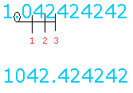

Again, moving a decimal point three places to the right is done by multiplying the decimal number by 1000.
When you multiply one side by a number, you have to multiply the other side by the same number to keep the equation balanced
Thus, 1000x = 1042.42424242
Step 4:
Place the repeating digits to the right of the decimal point.
In this example, the repeating digit is not immediately to the right of the decimal point.
Look at the equation in step 1 one more time and you will see that there is a zero between the repeating digit and the decimal point.
To accomplish this, you have to move the decimal point 1 place to the right.
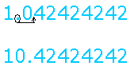

This is done by multiplying both sides by 10.

10x = 10.4242424242
Step 5:
Your two equations are:
1000x = 1042.42424242
10x = 10.42424242
1000x - 10x = 1042.42424242 − 10.42424242
990x = 1032
Divide both sides by 990

- KT0403 Symbols for irrational numbers
Irrational Meaning: The meaning of irrational is not having a ratio or no ratio can be written for that number. That means the number which cannot be expressed other than by means of roots. In other words, we can say that irrational numbers cannot be represented as the ratio of two integers.

How do you know a number is irrational?
The real numbers which cannot be expressed in the form of p/q, where p and q are integers and q ≠ 0 are known as irrational numbers. For example √ 2 and √ 3 etc. are irrational. Whereas any number which can be represented in the form of p/q, such that, p and q are integers and q ≠ 0 is known as a rational number.

Is Pi an irrational number?
Pi (π) is an irrational number because it is non-terminating. The approximate value of pi is 22/7. Also, the value of π is 3.14159 26535 89793 23846 264…

Symbol
Generally, the symbol used to represent the irrational symbol is “P”. Since the irrational numbers are defined negatively, the set of real numbers (R) that are not the rational number (Q), is called an irrational number. The symbol P is often used because of the association with the real and rational number. (i.e) because of the alphabetic sequence P, Q, R. But mostly, it is represented using the set difference of the real minus rationals, in a way R- Q or R\Q.

Properties
Since irrational numbers are the subsets of the real numbers, irrational numbers will obey all the properties of the real number system. The following are the properties of irrational numbers:
The addition of an irrational number and a rational number gives an irrational number. For example, let us assume that x is an irrational number, y is a rational number and the addition of both the numbers x +y gives a rational number z.
Multiplication of any irrational number with any nonzero rational number results in an irrational number. Let us assume that if xy=z is rational, then x =z/y is rational, contradicting the assumption that x is irrational. Thus, the product xy must be irrational.
The least common multiple (LCM) of any two irrational numbers may or may not exist.
The addition or the multiplication of two irrational numbers may be rational; for example, √2. √2 = 2. Here, √2 is an irrational number. If it is multiplied twice, then the final product obtained is a rational number. (i.e) 2.
The set of irrational numbers is not closed under the multiplication process, unlike the set of rational numbers.

- KT0404 Rounding prematurely in calculations
What Is a Rounding Error?
A rounding error, or round-off error, is a mathematical miscalculation or quantization error caused by altering a number to an integer or one with fewer decimals. Basically, it is the difference between the result of a mathematical algorithm that uses exact arithmetic and that same algorithm using a slightly less precise, rounded version of the same number or numbers. The significance of a rounding error depends on the circumstances.

While it is inconsequential enough to be ignored in most cases, a rounding error can have a cumulative effect in the present-day computerized financial environment, in which case it may need to be rectified. A rounding error can be especially problematic when rounded input is used in a series of calculations, causing the error to compound, and sometimes to overpower the calculation

A rounding error, or round-off error, is a mathematical miscalculation or quantization error caused by altering a number to an integer or one with fewer decimals.

- KT0405 Accuracy
Accuracy and precision are two measures of observational error. Accuracy is how close or far off a given set of measurements (observations or readings) are to their true value, while precision is how close or dispersed the measurements are to each other.

In other words, precision is a description of random errors, a measure of statistical variability. Accuracy has two definitions:
More commonly, it is a description of only systematic errors, a measure of statistical bias of a given measure of central tendency; low accuracy causes a difference between a result and a true value; ISO calls this trueness.
Alternatively, ISO defines accuracy as describing a combination of both types of observational error (random and systematic), so high accuracy requires both high precision and high trueness.

- KT0406 Final value of a calculation expressed in terms of the required unit

How do you calculate the value of expression?
To evaluate an algebraic expression, you have to substitute a number for each variable and perform the arithmetic operations. In the example above, the variable x is equal to 6 since 6 + 6 = 12. If we know the value of our variables, we can replace the variables with their values and then evaluate the expression.
What is the value of an expression?
The value of a mathematical expression is the result of the computation described by this expression when the variables and constants in it are assigned values. The value of a function, given the value(s) assigned to its argument(s), is the quantity assumed by the function for these argument values.

Evaluate expressions
A variable is a letter, for example x, y or z, that represents an unspecified number.

6+x=12
To evaluate an algebraic expression, you have to substitute a number for each variable and perform the arithmetic operations. In the example above, the variable x is equal to 6 since 6 + 6 = 12.

If we know the value of our variables, we can replace the variables with their values and then evaluate the expression.
Example
Calculate the following expression for x=3 and z=2
6z+4x=?6z+4x=?
Solution: Replace x with 3 and z with 2 to evaluate the expression.
6z+4x=?6z+4x=?
6⋅2+4⋅3=?6⋅2+4⋅3=?
12+12=24

Internal Assessment Criteria and Weight

- IAC0401 The effect of error in calculations is reasoned

KM-06-KT06 : Cartesian coordinate system
Learning Outcome
- KT0501 Definition
- KT0502 Terminology
- KT0503 The coordinate plane
- KT0504 Intersecting x- and y-axes
- KT0505 Four quadrants
- KT0506 Naming using Roman numerals
- KT0507 Use and application – creating graphs and maps

- KT0501 Definition
A Cartesian coordinate system in a plane is a coordinate system that specifies each point uniquely by a pair of numerical coordinates, which are the signed distances to the point from two fixed perpendicular oriented lines, measured in the same unit of length.

- KT0502 Terminology
What is Cartesian coordinate system with example?
The Cartesian coordinate system uses a horizontal axis that is called the x-axis and a vertical axis called the y-axis. Equations for lines in this system will have both the x and y variable. For example, the equation 2x + y = 2 is an example of a line in this system

What are the labels of the Cartesian coordinate system?
The Cartesian coordinate system consists of two axes (plural of axis) drawn at right angles to one-another. The vertical axis is called the ordinate, and is usually labeled as the y-axis. The horizontal axis is called the abscissa and is usually labeled as the x-axis.
A Cartesian coordinate system in a plane has two perpendicular lines (the x-axis and y-axis); in three-dimensional space, it has three (the x-axis, y-axis, and z-axis). Compare polar coordinate system.

- KT0503 The coordinate plane
What is Coordinate Plane?
A coordinate plane is a two-dimensional plane formed by the intersection of a vertical line called y-axis and a horizontal line called x-axis. These are perpendicular lines that intersect each other at zero, and this point is called the origin. The axes cut the coordinate plane into four equal sections, and each section is known as quadrant as shown below.
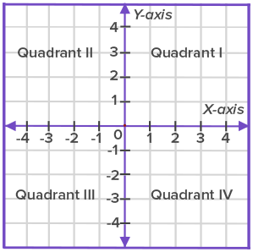

- The two-dimensional plane is called the Cartesian plane, or the coordinate plane and the axes are called the coordinate axes or x-axis and y-axis.
- The given plane has four equal divisions by origin called quadrants. Quadrant 1, Quadrant 2, Quadrant 3 and Quadrant 4 show the division of the quadrant plane.
- The horizontal line towards the right of the origin (denoted by O) is positive x-axis
- The horizontal line towards the left of the origin is negative x-axis.
- The vertical line above the origin is positive y-axis.
- The vertical line below the origin is negative y-axis.
The given conventions are followed to locate the coordinates of a point:
The x-coordinate or abscissa of a point is its perpendicular distance from the y-axis measured along the x-axis.
The y-coordinate or ordinate of a point is its perpendicular distance from the x-axis measured along the y-axis.
In stating the coordinates of a point in the coordinate plane, the x-coordinate comes first, and then comes the y-coordinate. We place the coordinates in brackets as (x, y).
So, in the given graph, coordinates of A are (5, 6) as it is 5 units away from the origin on positive x-axis and 6 units away from the origin on the positive y-axis.

Can you tell the coordinates of B, D, E, and F?
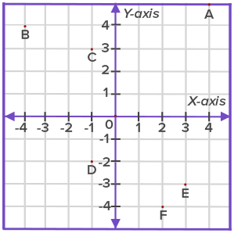
If a point is made somewhere on the graph as shown in the figure, how is its position represented?
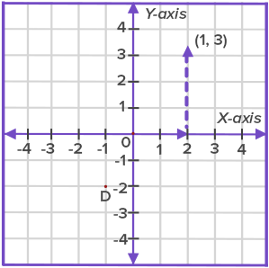

To plot the ordered pair (1, 3) in the coordinate plane:
- First, plot the number 1 on the x-coordinate as it comes first in the ordered pair. Since it is a positive number, it should move 1 unit from the origin to the right.
- Next, plot the number 3 on the y-axis. As it is a positive number, so it would move 3 units up on the y-axis.
- The graphical representation of the ordered pair (1, 3) is shown in the figure.

- KT0504 Intersecting x- and y-axes
The horizontal axis is called the x-axis, and the vertical axis is called the y-axis. The two intersecting axes form four quadrants, numbered I through IV. The point of intersection (0, 0) is called the origin. In an ordered pair, the x-coordinate is always listed first and the y-coordinate second.
The coordinate system is a grid system, similar to a map. Its lines are formed by two axes that are drawn perpendicular to each other. The horizontal axis is called the x-axis, and the vertical axis is called the y-axis. The two intersecting axes form four quadrants, numbered I through IV.
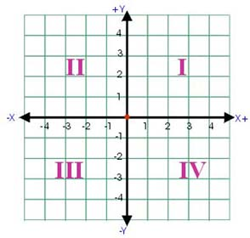

- KT0505 Four quadrants
What are the 4 quadrants?
Here are the characteristics for each of the four coordinate plane quadrants:
- Quadrant I: positive x and positive y.
- Quadrant II: negative x and positive y.
- Quadrant III: negative x and negative y.
- Quadrant IV: positive x and negative y.

What Are the Four Coordinate Plane Quadrants?
There are four coordinate plane quadrants you’ll need to know when plotting points or graphing lines on the coordinate plane. The coordinate plane, also known as the coordinate grid, cartesian coordinate system, or Cartesian plane, is constructed by taking a vertical axis, or the y-axis and setting it against a horizontal axis, or the x-axis. This creates a grid with four quadrants.

The four coordinate plane quadrants don't have names but are simply known as the first quadrant, second quadrant, third quadrant, and fourth quadrant.

Characteristics of Each of the Coordinate Plane Quadrants
As we know, each ordered pair of a point on the graph has an x-coordinate and a y-coordinate. In each pair of numbers, the first number represents the x-coordinate, and the second number represents the y-number. Each axis is a number line (horizontal number line for the x-axis, and vertical number line for the y-axis) that goes on forever in the negative direction (negative infinity) and positive direction (positive infinity).

On the x-axis, a positive x coordinate will be in the right quadrants and a negative x coordinate will be in the left quadrants. For the y-axis, a positive y-coordinate will be on the top half and a negative y-coordinate will be on the bottom half. Here are the characteristics for each of the four coordinate plane quadrants:

- Quadrant I: positive x and positive y
- Quadrant II: negative x and positive y
- Quadrant III: negative x and negative y
- Quadrant IV: positive x and negative y
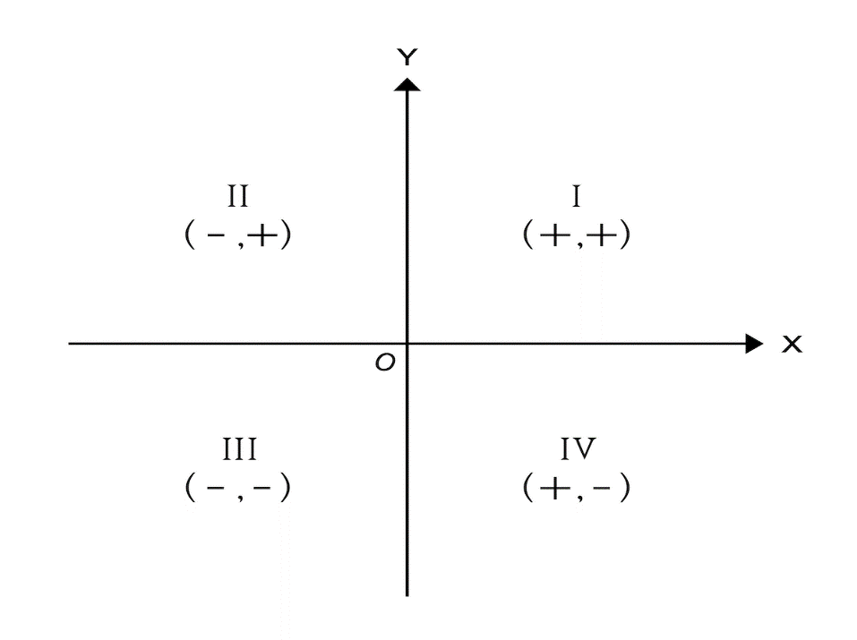

Understanding the Four Coordinate Plane Quadrants
Knowing the characteristics for each of the quadrants means you can place a list of plot points simply by looking at the x values and y values and seeing whether they are positive numbers or negative numbers.

For example, a coordinate pair of (1, 4) will be in Quadrant I because both the x-value and y-value are positive. A coordinate pair of (-3, -3) will be in Quadrant III because both the x-value and the y-value are positive. And that’s all you need to know regarding the four coordinate plane quadrants on the Cartesian plane!
The four quadrants
The coordinate axes divide the plane into four quadrants, labelled first, second, third and fourth as shown. Angles in the third quadrant, for example, lie between 180∘180∘ and 270∘270∘.
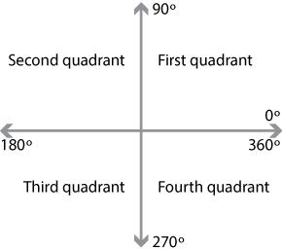
By considering the xx- and yy-coordinates of the point PP as it lies in each of the four quadrants, we can identify the sign of each of the trigonometric ratios in a given quadrant. These are summarised in the following diagrams.
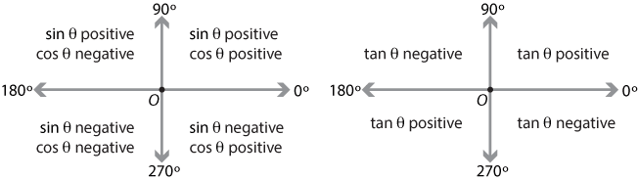
Detailed description of diagram
Related angles
In the module Further trigonometry (Year 10), we saw that we could relate the sine and cosine of an angle in the second, third or fourth quadrant to that of a related angle in the first quadrant. The method is very similar to that outlined in the previous section for angles in the second quadrant.
We will find the trigonometric ratios for the angle 210∘210∘, which lies in the third quadrant. In this quadrant, the sine and cosine ratios are negative and the tangent ratio is positive.
To find the sine and cosine of 210∘210∘, we locate the corresponding point PP in the third quadrant. The coordinates of PP are (cos210∘,sin210∘)(cos⁡210∘,sin⁡210∘). The angle POQPOQ is 30∘30∘ and is called the related angle for 210∘210∘.
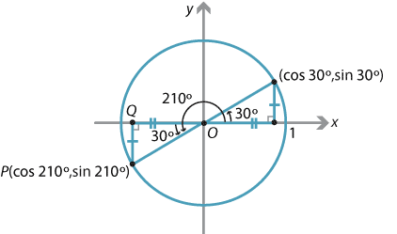
Detailed description of diagram
So,
cos210∘=−cos30∘=−3–√2andsin210∘=−sin30∘=−12.cos⁡210∘=−cos⁡30∘=−32andsin⁡210∘=−sin⁡30∘=−12.
Hence
tan210∘=tan30∘=13–√.tan⁡210∘=tan⁡30∘=13.
In general, if θθ lies in the third quadrant, then the acute angle θ−180∘θ−180∘ is called the related angle for θθ.
Exercise 2
- Use the method illustrated above to find the trigonometric ratios of 330∘330∘.
- Write down the related angle for θθ, if θθ lies in the fourth quadrant.
The basic principle for finding the related angle for a given angle θθ is to subtract 180∘180∘ from θθ or to subtract θθ from 180∘180∘ or 360∘360∘, in order to obtain an acute angle. In the case when the related angle is one of the special angles 30∘30∘, 45∘45∘ or 60∘60∘, we can simply write down the exact values for the trigonometric ratios.
In summary, to find the trigonometric ratio of an angle between 0∘0∘ and 360∘360∘:
- find the related angle
- obtain the sign of the ratio by noting the quadrant
- evaluate the trigonometric ratio of the related angle and attach the appropriate sign.

- KT0506 Naming using Roman numerals
Use Roman numerals only when naming ionic compounds that have cations with more than one possible positive charge. If you place Roman numerals in all compound names, they will be wrong when misapplied.
Roman numerals are the symbols used in a system of numerical notation based on the ancient Roman system. The symbols are I, V, X, L, C, D, and M, standing respectively for 1, 5, 10, 50, 100, 500, and 1,000.

- KT0507 Use and application – creating graphs and maps
How do you make a map graph?
- Create a Map chart with Data Types
- Map charts have gotten even easier with geography data types. ...
- Now it's time to create a map chart, so select any cell within the data range, then go to the Insert tab > Charts > Maps > Filled Map.
- If the preview looks good, then press OK.

Internal Assessment Criteria and Weight

- IAC0501 The Cartesian coordinate system is explained in terms of application and the use of correct terminology

KM-06-KT07 : Pythagorean theorem for finding the distance between two points
Learning Outcome
- KT0601 Definition
- KT0602 Terminology
- KT0603 Purpose
- KT0604 Determine the distance between two points on the Cartesian grid

- KT0601 Definition
What is a Pythagorean theorem and what is it used for?
The Pythagorean Theorem is a useful tool that shows how the sum of the areas of three intersecting squares can determine the side lengths of a right triangle. This theorem is an extremely useful tool that provides the basis for more complex trigonometry theories such as the converse of the Pythagorean theorem.

- KT0602 Terminology
- Right triangle
a triangle with one right angle
In mathematics, the Pythagorean theorem or Pythagoras' theorem is a relation in Euclidean geometry among the three sides of a right triangle (right-angled triangle).
- Coordinate System
a system that uses coordinates to establish position
...
- Theorem
an idea accepted as a demonstrable truth
In mathematics, the Pythagorean theorem or Pythagoras' theorem is a relation in Euclidean geometry among the three sides of a right triangle (right-angled triangle).
- Hypotenuse
the side of a right triangle opposite the right angle
In terms of areas, it states:
In any right triangle, the area of the square whose side is the hypotenuse (the side opposite the right angle) is equal to the sum of the areas of the squares whose sides are the two legs (the two sides that meet at a right angle).
- Pythagorean
of or relating to Pythagoras or his geometry
In mathematics, the Pythagorean theorem or Pythagoras' theorem is a relation in Euclidean geometry among the three sides of a right triangle (right-angled triangle).
- Dimensional
relating to coordinates that determine a position in space
The theorem can be generalized in various ways, including higher- dimensional spaces, to spaces that are not Euclidean, to objects that are not right triangles, and indeed, to objects that are not triangles at all, but n-dimensional solids.
- Algebraic
of or relating to algebra
These are very diverse, including both geometric proofs and algebraic proofs, with some dating back thousands of years.
- Geometry
the mathematics of points and lines and curves and surfaces
In mathematics, the Pythagorean theorem or Pythagoras' theorem is a relation in Euclidean geometry among the three sides of a right triangle (right-angled triangle).
- Right angle
the 90 degree angle between two perpendicular lines
In terms of areas, it states:
In any right triangle, the area of the square whose side is the hypotenuse (the side opposite the right angle) is equal to the sum of the areas of the squares whose sides are the two legs (the two sides that meet at a right angle).
- Pythagoras
Greek philosopher and mathematician who proved the Pythagorean theorem; considered to be the first true mathematician (circa 580-500 BC)
In mathematics, the Pythagorean theorem or Pythagoras' theorem is a relation in Euclidean geometry among the three sides of a right triangle (right-angled triangle).
- Equation
a mathematical statement that two expressions are the same
The theorem can be written as an equation relating the lengths of the sides a, b and c, often called the Pythagorean equation:
where c represents the length of the hypotenuse, and a and b represent the lengths of the other two sides.
- Angle
the space between two lines or planes that intersect
In mathematics, the Pythagorean theorem or Pythagoras' theorem is a relation in Euclidean geometry among the three sides of a right triangle (right- angled triangle).
- Formula
a group of symbols that make a mathematical statement
There is evidence that Babylonian mathematicians understood the formula, although there is little surviving evidence that they fitted it into a mathematical framework.

- KT0603 Purpose
Pythagoras determined that when three squares are arranged so that they form a right angle triangle, the largest of the three squares must have the same area as the other two squares combined. In the picture below, you can see how the sum of the squares creates the right triangle ABC.
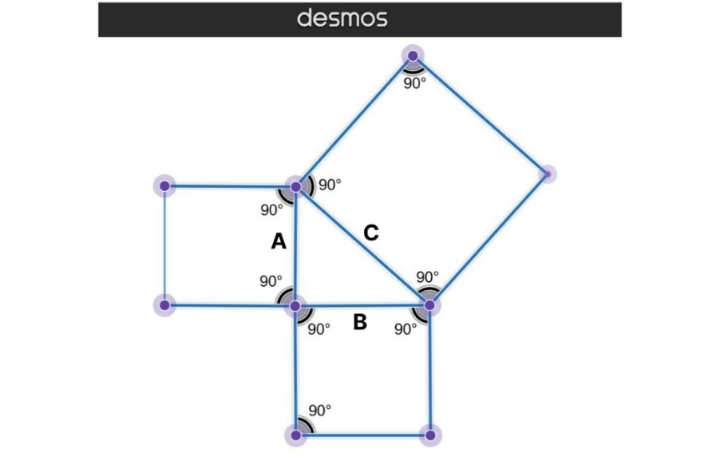
This realization about the area of the squares led to the Pythagoras theorem:
Squares are different from other parallelograms and trapezoids because all their sides are equal lengths. So since squares are made up of four equal sides, you can see that each individual square makes up a side of the right triangle.
The length of the largest square, which we'll call length c, is the length of the hypotenuse. (The hypotenuse is the longest side of a right triangle.) The smaller squares make up the other two sides of the right triangle.
Breaking Down the Pythagorean Theorem
Let's get into the dissection and proof of the Pythagorean theorem. The Pythagorean theorem states:
- The legs of a right triangle that are adjacent to a 90-degree angle must be squared and added together.
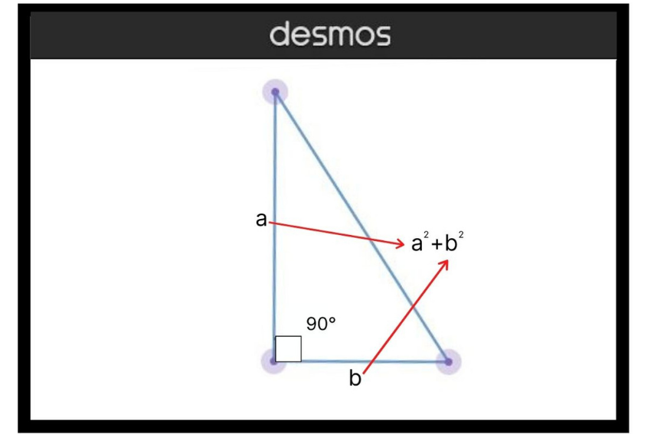
- The length of the third side, the hypotenuse of a right triangle, must also be squared.
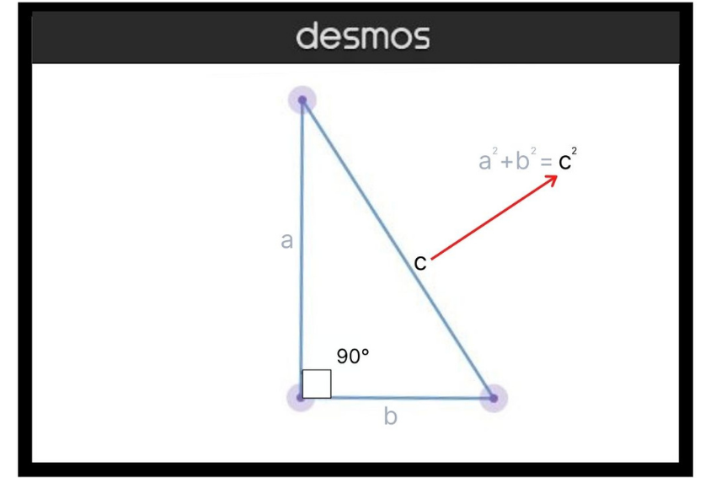
- You must then take the square of the length of the hypotenuse and the square root of the other two sides of a right triangle to solve the equation.
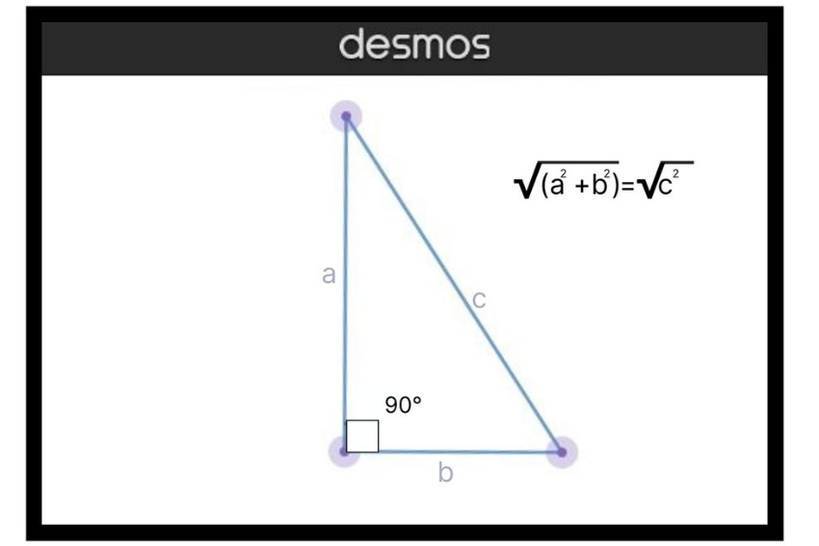
The Answer To ‘What Is the Pythagorean Theorem’
The Pythagorean Theorem is a useful tool that shows how the sum of the areas of three intersecting squares can determine the side lengths of a right triangle.

- KT0604 Determine the distance between two points on the Cartesian grid
What is Cartesian grid plan?
Cartesian grids are composed of squares (cubes in 3D), which are aligned with the Cartesian coordinate axes. Cartesian grids can be generated easily and with low computational effort even for geometrically complex domains.

Three dimensions
A Cartesian coordinate system for a three-dimensional space consists of an ordered triplet of lines (the axes) that go through a common point (the origin), and are pair-wise perpendicular; an orientation for each axis; and a single unit of length for all three axes.

Internal Assessment Criteria and Weight

- IAC0601 The Pythagorean theorem is explained in terms of application and the use of correct terminology

KM-06-KT08 : Operator precedence
Learning Outcome
- KT0701 Definition and terminology
- KT0702 Purpose and use
- KT0703 Order of operations (left to right)
- KT0704 Apply precedence:
    - Parentheses
    - Multiply and divide
    - Add and subtract
- KT0705 Use of PEDMAS in programming

- KT0701 Definition and terminology
What is a precedence of operators?
The precedence of an operator specifies how "tightly" it binds two expressions together. For example, in the expression 1 + 5 * 3 , the answer is 16 and not 18 because the multiplication ("*") operator has a higher precedence than the addition ("+") operator. Parentheses may be used to force precedence, if necessary.
What is precedence of operators with example?
The precedence of operators determines which operator is executed first if there is more than one operator in an expression. Let us consider an example: int x = 5 - 17* 6; In C, the precedence of * is higher than - and = .
What is precedence of operators with example?
The precedence of operators determines which operator is executed first if there is more than one operator in an expression. Let us consider an example: int x = 5 - 17* 6; In C, the precedence of * is higher than - and = .

- KT0702 Purpose and use
What is the use of operators precedence?
The precedence of an operator specifies how "tightly" it binds two expressions together. For example, in the expression 1 + 5 * 3 , the answer is 16 and not 18 because the multiplication ("*") operator has a higher precedence than the addition ("+") operator. Parentheses may be used to force precedence, if necessary.

What is the importance of operator precedence and associativity?
Operator precedence determines which operator is performed first in an expression with more than one operators with different precedence. Operators Associativity is used when two operators of same precedence appear in an expression. Associativity can be either Left to Right or Right to Left.
- KT0703 Order of operations (left to right)
What is the order of precedence for operators?
Operators are listed in descending order of precedence. If several operators appear on the same line or in a group, they have equal precedence. All simple and compound-assignment operators have equal precedence. An expression can contain several operators with equal precedence
The order of operations, which is used throughout mathematics, science, technology and many computer programming languages, is expressed here:

exponentiation and root extraction
multiplication and division
addition and subtraction
This means that if, in a mathematical expression, a subexpression appears between two operators, the operator that is higher in the above list should be applied first.

The commutative and associative laws of addition and multiplication allow adding terms in any order, and multiplying factors in any order—but mixed operations must obey the standard order of operations.

In some contexts, it is helpful to replace a division with multiplication by the reciprocal (multiplicative inverse) and a subtraction by addition of the opposite (additive inverse). For example, in computer algebra, this allows one to handle fewer binary operations, and makes it easier to use commutativity and associativity when simplifying large expressions (for more, see Computer algebra § Simplification). Thus 3 ÷ 4 = 3 ×
1
/
4
; in other words, the quotient of 3 and 4 equals the product of 3 and
1
/
4
. Also 3 − 4 = 3 + (−4); in other words the difference of 3 and 4 equals the sum of 3 and −4. Thus, 1 − 3 + 7 can be thought of as the sum of 1 + (−3) + 7, and the three summands may be added in any order, in all cases giving 5 as the result.

The root symbol √ is traditionally prolongated by a bar (called vinculum) over the radicand (this avoids the need for parentheses around the radicand). Other functions use parentheses around the input to avoid ambiguity.[a] The parentheses can be omitted if the input is a single numerical variable or constant[1] (as in the case of sin x = sin(x) and sin π = sin(π).[a] Another shortcut convention that is sometimes used is when the input is monomial; thus, sin 3x = sin(3x) rather than (sin(3)) x, but sin x + y = sin(x) + y, because x + y is not a monomial. This, however, is ambiguous and not universally understood outside of specific contexts.[b] Some calculators and programming languages require parentheses around function inputs, some do not.

- KT0704 Apply precedence:

Apply precedence
- Use apply precedence to set a precedence for IP packets.
- Use undo apply precedence to restore the default.

Syntax
- apply precedence { type | value }

- undo apply precedence

Default
- No precedence is set for IP packets.
Views
- Policy node view
- Predefined user roles
- network-admin
Parameters
- type: Specifies the precedence type for IP packets.
- value: Specifies the precedence for IP packets. Eight precedence values (0 to 7) are available. Each precedence value corresponds to a precedence type, as shown in Table 119. You can set either a precedence value or a precedence type for IP packets.
Meaning of Precedence
Perhaps partly influenced by French précédence, meaning "priority" or "pre-eminence," English precedence began being used in the late 1500s in senses relating to order and rank. Specifically, it came to denote priority of importance, or the superiority of rank at a ceremonial or formal social gathering—for example, guests at a banquet might be introduced or seated "in order of precedence." Idiomatically, precedence is often used with the verbs take, have, or give. Family matters can be said to "take/have precedence" over one's job, for instance; or a piece of legislation might "give precedence" to big business.

Meaning of Precedent
On the other hand, the noun precedent is frequently used in the phrase "to set a precedent," meaning "to set an example or rule to be followed." The word is often used in legal contexts, where it denotes a judicial decision that should be followed by a judge when deciding a later similar case. When something contradicts an established precedent or prevailing custom or practice, it is said to "break with precedent" or "go against precedent." Another common collocation is "without precedent" in reference to something not supported by a prior example or ruling. More commonly, something said to be "without precedent" is unprecedented. Both unprecedented and precedented appear in the English language in the 17th century.

- KT0705 Use of PEDMAS in programming
Which is correct Pemdas or Pedmas?
PEMDAS (The multiplication comes before division) PEDMAS (The division comes before multiplication) PE(MD)AS (Division and Multiplication have the same weight, it depends what is left)

Multiplication and division come before addition and subtraction is a rule we learned in grade school. This rule still works. A common mnemonic to remember this rule is PEMDAS, or Please Excuse My Dear Aunt Sally. Precedence rules may vary from one programming language to another.

Internal Assessment Criteria and Weight
- IAC0701 Operator precedence is explained in terms of application and the use of correct terminology

KM-06-KT09 : Integer division
Learning Outcome
- KT0801 Definition and terminology
- KT0802 Purpose and use
- KT0803 Rules on how to divide integers
- KT0804 Names and symbols for integer division
- KT0805 Software for integer division

- KT0801 Definition and terminology
Integer division is division in which the fractional part (remainder) is discarded is called integer division and is sometimes denoted. Integer division can be defined as , where "/" denotes normal division and is the floor function.

What is integer division in Python?
Answer. Integer division is the division of one integer by another in which the resulting number is truncated (ie. decimal places are dropped), such that the quotient is also an integer. This is the default behavior in Python 2.7, but not Python 3. For example, 3 / 2 returns 1 in Python 2.7, but 1.5 in Python 3.
- KT0802 Purpose and use
What is the purpose of division?
The main goal of the division is to see how many equal groups or how many in each group when sharing fairly.
What is Division?
The division is a method of distributing a group of things into equal parts. It is one of the four basic operations of arithmetic, which gives a fair result of sharing.
The division is an operation inverse of multiplication. If 3 groups of 4 make 12 in multiplication; 12 divided into 3 equal groups give 4 in each group in division.
The main goal of the division is to see how many equal groups or how many in each group when sharing fairly.
For example:
There are 16 balls and 4 boxes, how to put 16 balls into four equal sized boxes?


So, 16 divided by 4 =?
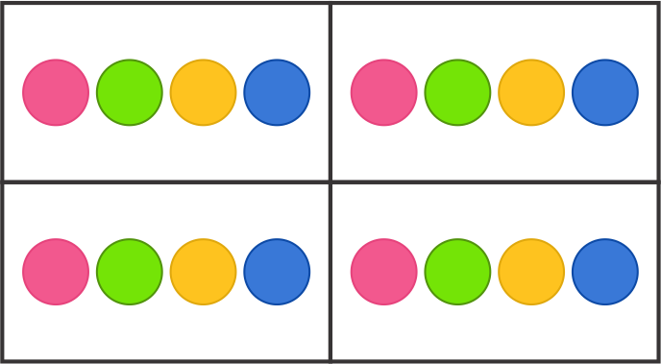
Therefore, 4 balls should be kept in each box.
Mathematical notation for division
There are various signs which can be used to indicate division such as ÷, /.
For example:
- 8 ÷ 2
- 8/2

Special names for each character in Division
Each part involved in a division equation has a special name.
Dividend ÷ divisor = quotient
Dividend: The dividend is the number that is being divided in the division process.
Divisor:The number by which dividend is being divided by is called divisor.
Quotient: A quotient is a result obtained in the division process.
18 ÷ 3 = 6

Dividend divisor quotient
So, in the above process where we divided 16 balls into 4 equal groups;
The dividend is 16, the divisor is 4 and thus the quotient is 4.

Introduction to the remainder
The remainder is the portion of the dividend that is left over after division. For example, on dividing 83 by 2, there is a leftover of 1.
It means, 83 ÷ 2 = 41 and r =1,
Here, ‘r’ is remainder.

Special facts about division
- When dividing something by 1, the answer will always be the original number. It means if the divisor is 1, the quotient will always be equal to the dividend such as 10 ÷ 1= 10.
- Division by 0 is undefined.
- The division of the same dividend and divisor is always 1. For example: 4 ÷

- KT0803 Rules on how to divide integers
RULE 1: The quotient of a positive integer and a negative integer is negative.
RULE 2: The quotient of two positive integers is positive.
RULE 3: The quotient of two negative integers is positive. If the signs are different the answer is negative.
What is the Rule of Division of Integers?
- Positive ÷ positive = positive.
- Negative ÷ negative = positive.
- Negative ÷ positive = negative.

MULTIPLICATION
- RULE 1: The product of a positive integer and a negative integer is negative.
- RULE 2: The product of two positive integers is positive.
- RULE 3: The product of two negative integers is positive.

Examples:
- Rule 1: 1. (+4) x (-2) = -8 2. (-2) x (+5) = -10
- Rule 2: 1. (+6) x (+8) = +48 2. (+6) x (+2) = +12
- Rule 3: 1. (-6) x (-8) = +48 2. (-2) x (-4) = +8

DIVISION
- RULE 1: The quotient of a positive integer and a negative integer is negative.
- RULE 2: The quotient of two positive integers is positive.
- RULE 3: The quotient of two negative integers is positive.

Examples:
Rule 1: 1. (-8) / (+4) = -2 2. (-12) / (+6) = -2
Rule 2: 1. (+6) / (-3) = -2 2. (+24) / (-6) = -4
Rule 3. 1. (+9) / (+3) = +3 2. (+16) / (+4) = +4
Rule 4: 1. (-6) / (-2) = +3 2. (-42) / (-7) = +6

- KT0804 Names and symbols for integer division
What are the symbols for division?
The symbol for division, or sharing into equal groups, is ÷.
Names and symbols used for integer division include div, /, \, and %. Definitions vary regarding integer division when the dividend or the divisor is negative: rounding may be toward zero (so called T-division) or toward −∞ (F-division); rarer styles can occur

- KT0805 Software for integer division
What is integer division in programming?
The % (integer divide) operator divides two numbers and returns the integer part of the result. The result returned is defined to be that which would result from repeatedly subtracting the divisor from the dividend while the dividend is larger than the divisor.
What is integer division in Java?
Java does integer division, which basically is the same as regular real division, but you throw away the remainder (or fraction). Thus, 7 / 3 is 2 with a remainder of 1. Throw away the remainder, and the result is 2. Integer division can come in very handy.

Integer Division
/ is the division operator. If the types of the operands are double, then "real" division is performed. Real division is normal division as you learned in grade school. Division is approximate on a computer because you can't do infinitely precise division (recall that double values have finite precision, so there is usually a tiny, but unavoidable error representing real numbers). The result of dividing a double by a double is a double.
However, if both expressions have type int, then the result is an int. Does that sound strange? What is the result of evaluating 7 / 3?
Java does integer division, which basically is the same as regular real division, but you throw away the remainder (or fraction). Thus, 7 / 3 is 2 with a remainder of 1. Throw away the remainder, and the result is 2.

Integer division can come in very handy. Even if you don't see a use for it now, it is used quite often.
What happens if you really want an answer that's double. That is, you want the answer to be 2.33333333 or something close.
One way is to cast the denominator to double. You do this as 7 / (double) 3. Casting is an operator that creates a temporary double value. Thus it creates a temporary 3.0 double.

When one of the operands to a division is a double and the other is an int, Java implicitly (i.e. behind your back) casts the int operand to a double. Thus, Java performs the real division 7.0 / 3.0.

Internal Assessment Criteria and Weight

- IAC0801 Integer division is explained in terms of application and the use of correct terminology and symbols

KM-06-KT10 : Modulus
Learning Outcome
- KT0901 Definition and terminology
- KT0902 Purpose and use
- KT0903 Modulus abbreviated as “mod”
- KT0904 % application
- KT0905 (==) application
- KT0906 Modulus in programming

- KT0901 Definition and terminology
What is called modulus?
The modulo (or "modulus" or "mod") is the remainder after dividing one number by another. Example: 100 mod 9 equals 1. Because 100/9 = 11 with a remainder of 1. Another example: 14 mod 12 equals 2. Because 14/12 = 1 with a remainder of 2.
What is the modulus rule?
When we're working in modulus n, then any number in modulus n is equal to the remainder when that number is divided by n. Consider our modulus 7 example: 6 + 5 = 11. When we divide 11 by modulus 7, we get 1 with a remainder of 4; therefore, 6 + 5 = 4

- KT0902 Purpose and use
What operations use modulus?
In integer division and modulus, the dividend is divided by the divisor into an integer quotient and a remainder. The integer quotient operation is referred to as integer division, and the integer remainder operation is the modulus.
As a computer programmer, I use it frequently for a variety of purposes including time and patterns. For example, 325 seconds is equal to 5 minutes, 25 seconds. A similar application of modulus can be used to calculate hours, days, and longer periods of time. Modulus is also used in physics.

- KT0903 Modulus abbreviated as “mod”

Modulo is a math operation that finds the remainder when one integer is divided by another. In writing, it is frequently abbreviated as mod, or represented by the symbol %.

For two integers a and b:

a mod b = r
Where a is the dividend, b is the divisor (or modulus), and r is the remainder.

Examples
11 mod 4 = 3, because 11 divides by 4 (twice), with 3 remaining.

25 mod 5 = 0, because 25 divides by 5 (five times), with 0 remaining.
3 mod 2 = 1, because 3 divides by 2 (once), with 1 remaining.
5 mod 2 = 1, because all odd numbers yield a remainder of 1 when divided by 2.

Modular arithmetic and cryptography
Modular arithmetic is the field of mathematics which concerns these types of operations, where values "wrap around" (reset to zero) when they reach a modulus value. Modular arithmetic is extremely important in the field of cryptography, which encodes information using modulo operations with a very large modulus.
Practical Use of Modulus
Modulus is used for many things. Modulus is used in the c programming language and other languages. In c programming, it is known as the modulus operator. use them.

The modulo operator, denoted by %, is an arithmetic operator. The modulo division operator produces the remainder of an integer division. Syntax: If x and y are integers, then the expression: x % y. produces the remainder when x is divided by y.

How modulus works in a programming language. There is more to modulus than meets the eye. As a computer programmer, I use it frequently for a variety of purposes including time and patterns.

For example, 325 seconds is equal to 5 minutes, 25 seconds. A similar application of modulus can be used to calculate hours, days, and longer periods of time.

Modulus is also used in physics. as an example:- Young’s modulus (E) is a property of the material that tells us how easily it can stretch and deform and is defined as the ratio of tensile stress (σ) to tensile strain (ε). Where stress is the amount of force applied per unit area (σ = F/A) and strain is extension per unit length (ε = dl/l).

- KT0904 % application
What percent sign means?
The percent sign (%) is the symbol used to indicate a percentage, a number or ratio as a fraction of 100.
percent sign - a sign (`%') used to indicate that the number preceding it should be understood as a proportion multiplied by 100. percentage sign.

- KT0905 (==) application
What symbol means?
1 : something that stands for something else : emblem The eagle is a symbol of the United States. 2 : a letter, character, or sign used instead of a word to represent a quantity, position, relationship, direction, or something to be done The sign + is the symbol for addition.

- KT0906 Modulus in programming
What is modulus?
It's the other part of the answer for integer division. It's the remainder. Remember in grade school you would say, “Eleven divided by four is two remainder three.” In many programming languages, the symbol for the modulus operator is the percent sign (%).
Return Value:

If y completely divides x, the result of the expression is 0.
If x is not completely divisible by y, then the result will be the remainder in the range [1, x-1].
If x is 0, then division by zero is a compile-time error

In computing, the modulo operation returns the remainder or signed remainder of a division, after one number is divided by another (called the modulus of the operation).

Given two positive numbers a and n, a modulo n (often abbreviated as a mod n or as a % n) is the remainder of the Euclidean division of a by n, where a is the dividend and n is the divisor. The modulo operation is to be distinguished from the symbol mod, which refers to the modulus[1] (or divisor) one is operating from.

For example, the expression "5 mod 2" would evaluate to 1, because 5 divided by 2 has a quotient of 2 and a remainder of 1, while "9 mod 3" would evaluate to 0, because the division of 9 by 3 has a quotient of 3 and a remainder of 0; there is nothing to subtract from 9 after multiplying 3 times 3.

Although typically performed with a and n both being integers, many computing systems now allow other types of numeric operands. The range of values for an integer modulo operation of n is 0 to n − 1 inclusive (a mod 1 is always 0; a mod 0 is undefined, possibly resulting in a division by zero error in some programming languages). See Modular arithmetic for an older and related convention applied in number theory.
Internal Assessment Criteria and Weight

- IAC0901 Modulus is explained in terms of application and the use of correct terminology and symbols

KM-06-KT11 : Increments
Learning Outcome
- KT1001 Definition and terminology
- KT1002 Purpose and use
- KT1003 Increment a variable
- KT1004 compound assignment operator
- KT1005 Increments in programming

- KT1001 Definition and terminology
What are examples of increments?
The process of increasing or decreasing a numeric value by another value. For example, incrementing 2 to 10 by the number 2 would be 2, 4, 6, 8, 10. 2. An increment is also a programming operator to increase the value of a numerical value

An increment may refer to any of the following:
  - The process of increasing or decreasing a numeric value by another value. For example, incrementing 2 to 10 by the number 2 would be 2, 4, 6, 8, 10.
  - An increment is also a programming operator to increase the value of a numerical value. In Perl, a variable can be incremented by one by adding a ++ at the end of the variable. In the example below, the value variable is set as 1 and then incremented in value by one with the Rvalue++; line. Therefore, when this variable is printed it prints 2
my Rvalue = 1;
Rvalue++;
print "Rvalue\n";

  - With the processor ALU (arithmetic logic unit) arithmetic unit, increment is the operation of adding a 1 to a bit.

- KT1002 Purpose and use
What is the increment used for?
Increment is used in many technical fields, but also nontechnically. Incremental increases in drug dosages are used for experimental purposes. Incremental tax increases are easier to swallow than sudden large increases. Incremental changes of any kind may be hard to notice, but can be very significant in the long run.
What is Increments in statistics?
An increment is a small, unspecified, nonzero change in the value of a quantity. The symbol most commonly used is the uppercase Greek letter delta ( ). The concept is applied extensively in mathematical analysis and calculus.

- KT1003 Increment a variable
To increment a variable means to increase it by the same amount at each change. For example, your coder may increment a scoring variable by +2 each time a basketball goal is made. Decreasing a variable in this way is known as decrementing the variable value

How do you increment a variable by 1?
4.16. A program can increment by 1 the value of a variable called c using the increment operator, ++, rather than the expression c=c+1 or c+=1. An increment or decrement operator that is prefixed to (placed before) a variable is referred to as the prefix increment or prefix decrement operator, respectively.

A common way to change a variable value is to increment it. To increment a variable means to increase it by the same amount at each change. For example, your coder may increment a scoring variable by +2 each time a basketball goal is made. Decreasing a variable in this way is known as decrementing the variable value. Your coder may decrement a timer by –1 each time one second on the clock elapses.
Increment and decrement operators.
Operator | Called | Sample expression | Explanation
++ | preincrement | ++a | Increment a by 1, then use the new value of a in the expression in which a resides.
++ | postincrement | a++ | Use the current value of a in the expression in which a resides, then increment a by 1.
-- | predecrement | --b | Decrement b by 1, then use the new value of b in the expression in which b resides.
-- | postdecrement | b-- | Use the current value of b in the expression in which b resides, then decrement b by 1.

Adding or subtracting 1 from a variable is a very common programming practice. Adding 1 to a variable is called incrementing and subtracting 1 from a variable is called decrementing.

increment and decrement operators work only with integer variables -- not on floating point variables or literals.

the C++ compiler is controlling the execution of the prefix and postfix operators. You cannot change this order of execution. For example, the parentheses below will not force an early execution:
value = (((x--)))* num; //still decrements x last.

one disadvantage of using the increment/decrement operators is that the variable can only be incremented or decremented by the value ONE. If you need to increment (or decrement) by a larger (or smaller) value, you must use statements like
m += 2; or amount -= 5;

be careful when combining increment and decrement operators inside expressions with logical operators. If in doubt, don't use them together. For example, do NOT use:
if (( num1 = = 4 ) || ( num2 != ++j))
(j may not be incremented when (num1 = = 4) is TRUE.)
Instead, separate the code to avoid this problem:
++j;
if (( num1 = = 4) || (num2 != j))

- KT1004 Compound Assignment Operator
What is compound assignment operators with example?
Compound-assignment operators provide a shorter syntax for assigning the result of an arithmetic or bitwise operator. They perform the operation on the two operands before assigning the result to the first operand.

The compound assignment operators consist of a binary operator and the simple assignment operator. They perform the operation of the binary operator on both operands and store the result of that operation into the left operand, which must be a modifiable value.

- KT1005 Increments in programming

An increment is also a programming operator to increase the value of a numerical value. In Perl, a variable can be incremented by one by adding a ++ at the end of the variable. In the example below, the value variable is set as 1 and then incremented in value by one with the Rvalue++; line.
What is example of increment?
The definition of increment is the process of increasing by a specific amount, or the amount by which something increases. An example of an increment is an annual salary increase of 5%.

Increment and decrement operators are unary operators that add or subtract one, to or from their operand, respectively. They are commonly implemented in imperative programming languages. C-like languages feature two versions (pre- and post-) of each operator with slightly different semantics.

In languages syntactically derived from B (including C and its various derivatives), the increment operator is written as ++ and the decrement operator is written as --. Several other languages use inc(x) and dec(x) functions.

The increment operator increases, and the decrement operator decreases, the value of its operand by 1. The operand must have an arithmetic or pointer data type, and must refer to a modifiable data object. Pointers values are increased (or decreased) by an amount that makes them point to the next (or previous) element adjacent in memory.

In languages that support both versions of the operators:

The pre-increment and pre-decrement operators increment (or decrement) their operand by 1, and the value of the expression is the resulting incremented (or decremented) value.
The post-increment and post-decrement operators increase (or decrease) the value of their operand by 1, but the value of the expression is the operand's value prior to the increment (or decrement) operation.
In languages where increment/decrement is not an expression (e.g., Go), only one version is needed (in the case of Go, post operators only).

Since the increment/decrement operator modifies its operand, use of such an operand more than once within the same expression can produce undefined results. For example, in expressions such as x - ++x, it is not clear in what sequence the subtraction and increment operations should be performed. Such expressions generally invoke undefined behavior, and should be avoided.

Internal Assessment Criteria and Weight

- IAC1001 Increments are explained in terms of application and the use of correct terminology and symbols

KM-06-KT11 : Mixing types
Learning Outcome
- KT1101 Definition and terminology
- KT1102 Purpose and use
- KT1103 Apply an operator
- KT1104 Combination with the order of operations
- KT1105 The order in which an expression is written
- KT1106 How a computer would evaluate some expressions that combine types

- KT1101 Definition and terminology
How do you calculate mixing?
Divide 1 by the total number of parts (water + solution). For example, if your mix ratio is 8:1 or 8 parts water to 1 part solution, there are (8 + 1) or 9 parts. The mixing percentage is 11.1% (1 divided by 9).

How do you calculate mixing solutions?
Calculate appropriate v/v dilution using the formula C1V1 = C2V2 where C represents the concentration of the solute, and V represents volume in milliliters or ml. An example would be combining 95 percent ethanol with water to mix 100 ml of 70 percent ethanol. The calculation is 95% X V1 = 70% X 100ml.
- KT1102 Purpose and use
What is the purpose of mixing?
The goal of mixing is to bring out the best in your multi-track recording by adjusting levels, panning, and time-based audio effects (chorus, reverb, delay). The aim is to sculpt your arrangement to make sense of all your tracks in relation to each other.
Mix Ratios & Percentages
HOW TO CALCULATE PERCENTAGE IF MIX RATIO IS KNOWN
Divide 1 by the total number of parts (water + solution).
For example, if your mix ratio is 8:1 or 8 parts water to 1 part solution, there are (8 + 1) or 9 parts. The mixing percentage is 11.1% (1 divided by 9).

Need another example?
If your mix ratio is 4:1 or 4 parts water to 1 part solution, there are (4 + 1) or 5 parts. The mixing percentage is 20% (1 divided by 5).

HOW TO CALCULATE MIX RATIO IF PERCENTAGE IS KNOWN
(100 – the percentage): percentage
For example, if your percentage is 4%, take 100 – 4 (which is 96), so your mix ratio is 96:4 which can then be reduced to 24:1.

Need another example?
If your percentage is 10%, take 100 – 10 (which is 90), so your mix ratio is 90:10 which can be reduced to 9:1.

- KT1103 Apply an operator
The APPLY operator allows you to invoke a table-valued function for each row returned by an outer table expression of a query. The table-valued function acts as the right input and the outer table expression acts as the left input.
The APPLY operator allows you to invoke a table-valued function for each row returned by an outer table expression of a query. The table-valued function acts as the right input and the outer table expression acts as the left input. The right input is evaluated for each row from the left input and the rows produced are combined for the final output. The list of columns produced by the APPLY operator is the set of columns in the left input followed by the list of columns returned by the right input.

- KT1104 Combination with the order of operations
What is the correct order of operations in order?
We can remember the order using PEMDAS: Parentheses, Exponents, Multiplication and Division (from left to right), Addition and Subtraction (from left to right).
Which is example of combined operations?
For example: 3 x (2 + 4). First, we do the operation inside the parenthesis: 2 + 4 = 6. Then we perform the operation: 3 x 6 = 18. Step 2: perform multiplication and division, always from left to right

- KT1105 The order in which an expression is written
In mathematics and computer programming, the order of operations (or operator precedence) is a collection of rules that reflect conventions about which procedures to perform first in order to evaluate a given mathematical expression.

For example, in mathematics and most computer languages, multiplication is granted a higher precedence than addition, and it has been this way since the introduction of modern algebraic notation. Thus, the expression 1 + 2 × 3 is interpreted to have the value 1 + (2 × 3) = 7, and not (1 + 2) × 3 = 9. When exponents were introduced in the 16th and 17th centuries, they were given precedence over both addition and multiplication, and could be placed only as a superscript to the right of their base.Thus 3 + 52 = 28 and 3 × 52 = 75.

These conventions exist to eliminate notational ambiguity, while allowing notation to be as brief as possible. Where it is desired to override the precedence conventions, or even simply to emphasize them, parentheses ( ) can be used. For example, (2 + 3) × 4 = 20 forces addition to precede multiplication, while (3 + 5)2 = 64 forces addition to precede exponentiation. If multiple pairs of parentheses are required in a mathematical expression (such as in the case of nested parentheses), the parentheses may be replaced by brackets or braces to avoid confusion, as in [2 × (3 + 4)] − 5 = 9.

- KT1106 How a computer would evaluate some expressions that combine types
How do you evaluate expressions?
To evaluate an algebraic expression means to find the value of the expression when the variable is replaced by a given number. To evaluate an expression, we substitute the given number for the variable in the expression and then simplify the expression using the order of operations.

Internal Assessment Criteria and Weight

- IAC1101 Mixing types are explained in terms of application and the use of correct terminology and symbols

(

REFERENCE

://press.rebus.community › chapter › integer-division..
https://blog.mattclemente.com › 2019/07/12 › modulus..
https://en.wikipedia.org › wiki › Modulo_operation
https://codered.eccouncil.org › course › network-defens..
https://www.checkpoint.com › Secure The Network
https://www.sciencedirect.com › topics › computer-science
https://www.forcepoint.com › cyber-edu › defense-depth
https://www.cisco.com › Products & Services › Security
https://www.techtarget.com › searchsecurity › definition
https://www.itgovernance.co.uk › what-is-cybersecurity
https://www.gartner.com › topics › cybersecurity
https://www.ibm.com › za-en › topics › mobile-security
https://www.archonsecure.com › mobile-device-guide
https://preyproject.com › blog › what-are-cyber-threats-h..
https://emeritus.org › learn › different-types-of-cyber-s
https://www.simplilearn.com › cyber-security-tutorial

